To-Do List Web Application Project Report
Project Title
To-Do List Web Application
Introduction
It is a task management web application developed using HTML, CSS, and JavaScript. It helps users organize daily activities by creating, managing, and tracking tasks efficiently.
Objective
The objective of this project is to develop an interactive task management system that allows users to add, complete, delete, and filter tasks while maintaining data persistence through localStorage.
Technologies Used
- HTML5
- CSS3
- JavaScript (ES6)
- localStorage API
- Visual Studio Code
- GitHub
Features
- Add tasks
- Delete tasks
- Mark tasks as completed
- Filter tasks (All, Active, Done)
- Progress tracking
- Data persistence using localStorage
- Responsive user interface
Project Structure
- index.html
- style.css
- app.js
- README.md
Implementation
HTML was used to create the structure of the application. CSS was used for styling and responsive design. JavaScript was used for handling task operations such as adding, deleting, filtering, and storing tasks in localStorage.
Working Process
- User enters a task.
- Task is added to the task list.
- User can mark tasks as completed.
- User can delete unwanted tasks.
- Tasks are stored in localStorage.
- Data remains available after page refresh.
Screenshots
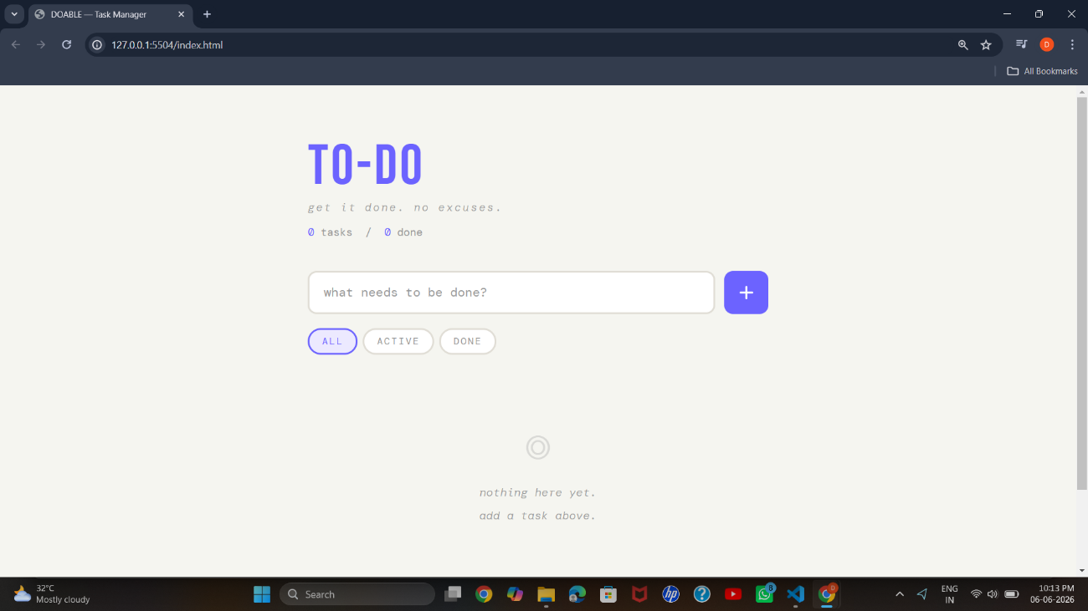

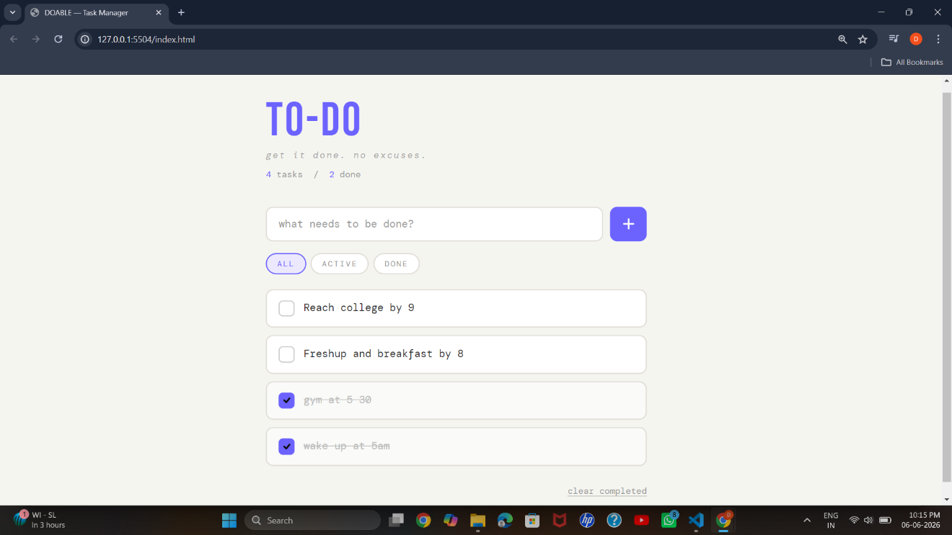

Challenges Faced
- Managing dynamic DOM updates
- Implementing localStorage functionality
- Creating an intuitive user interface
Learning Outcomes
- DOM Manipulation
- Event Handling
- JavaScript Functions
- Browser Storage APIs
- Responsive Web Design
Future Enhancements
- Task editing functionality
- Due dates and reminders
- Dark mode support
- User authentication
Conclusion
To-do app successfully provides a simple and efficient solution for task management. The project demonstrates practical implementation of front-end web development concepts and browser storage techniques.

